

**Software Design Specification**

**Project name: BoonBo Shop**

**Author: Group 5**

# **Record of changes**

| **Date** | **A, M, D** | **In charge** | **Description** |
| --- | --- | --- | --- |
|  |  |  |  |
|  |  |  |  |
|  |  |  |  |
|  |  |  |  |

*A - Added M - Modified D - Deleted

# **Table of Contents**

1. **Overview**………………………………………………….

1. Code Package

2. Database Design

a. Database Schema

b. Table Description

1. **Code Designs**.

1. <Feature/Function Name1>

a. Class Diagram.

b. Class Specifications.

c. Sequence Diagram(s).

d. Database queries.

2. <Feature/Function Name2>.

# **Overview**

## **Code package**

## **Database design**

1. **Database schema**

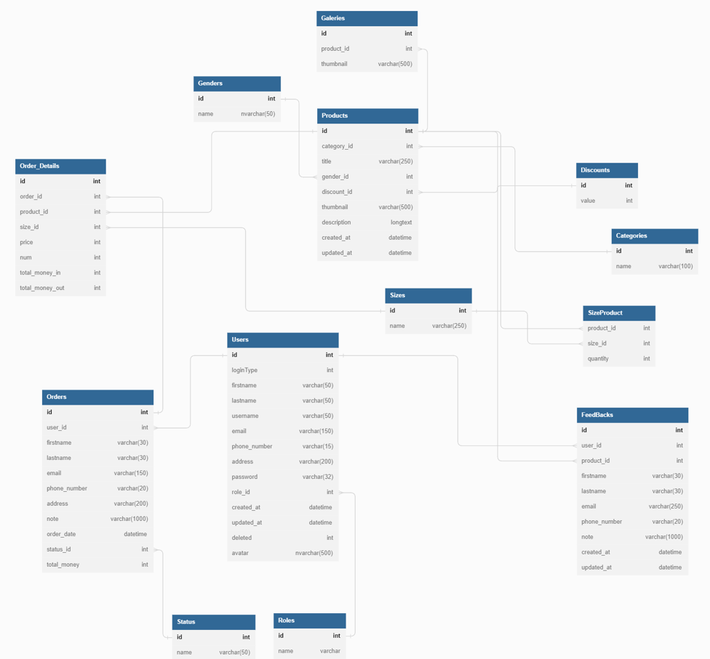

1. **Table description**

| **No** | **Table** | **Description** |
| --- | --- | --- |
| 1 | Users | Information of users |
| 2 | Roles | Role of users |
| 3 | Categories | Category of products |
| 4 | Products | Products of shop |
| 5 | Genders | Characteristics to classify products |
| 6 | Geleries | Images of products |
| 7 | Sizes | Size of products |
| 8 | SizeProduct | Classify products following sizes |
| 9 | Discounts | Discount offer for orders |
| 10 | Orders | Order placed by the customer |
| 11 | Order_Details | Detail about order |
| 12 | Status | Status of order |
| 13 | Feedbacks | Feedbacks of customers after buy product |

# **II.** **Code Designs**

1. **Register**
2. **Class Diagram**

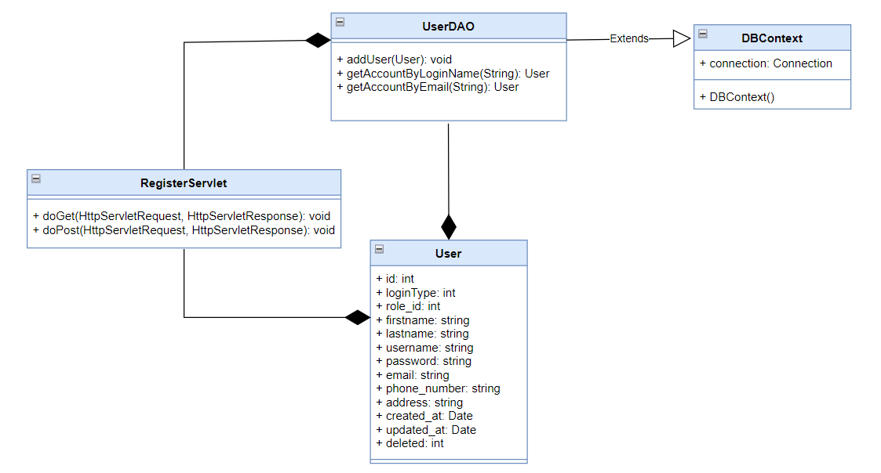

1. **Class specifications**

| **Class** | **Method** | **Description** |
| --- | --- | --- |
| UserDAO | addUser(User): void | Add new user in the table Users in the database. |
| getAccountByLoginName(String): User | Find the user who has the same username with the given string. If it exists, return User, else, return null. |
| getAccountByEmail(String): User | Find the user who has the same email with the given string. If it exists, return User, else, return null. |
| DBContext | DBContext() | Connect to the database |
| RegisterServlet | doGet() | Send request to JSP |
| doPost() | Get parameters from JSP and do addUser() method |

1. **Sequence Diagram**

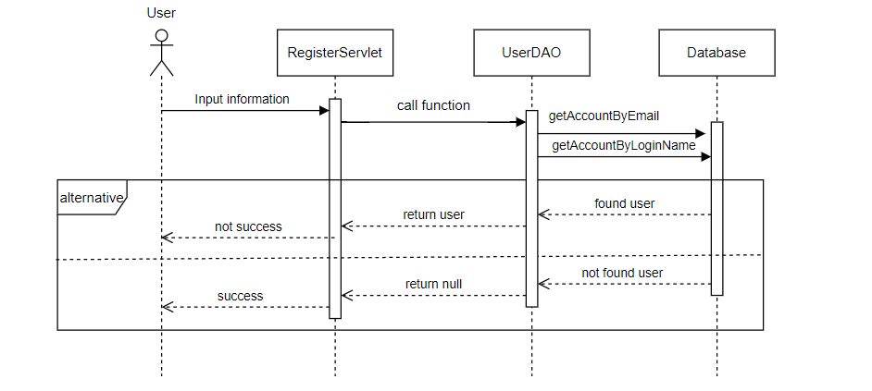

<https://app.diagrams.net/#G1QbCyYP93emWjfTfAVLbDhxN1eKG4w4V5>

1. **Database Queries**

| **Class** | **Method** | **SQL** |
| --- | --- | --- |
| UserDAO | addUser(User): void | INSERT INTO [dbo].[Users]  ………………  VALUES (1, 1, ?, ?, ?, ?, ?, ?, ?, ?, ?, ?)"; |
| getAccountByLoginName(String): User | Select * from Users where username = ? |
| getAccountByEmail(String): User | Select * from Users where email = ? |

**2. View profile**

1. **Class Diagram**

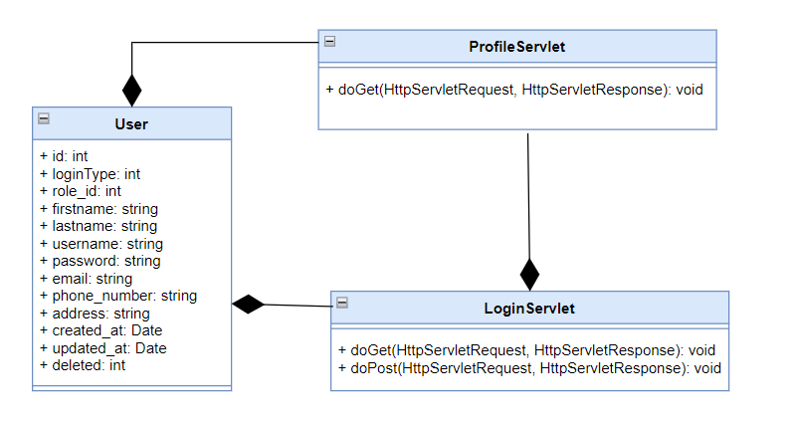

1. **Class specifications**

| **Class** | **Method** | **Description** |
| --- | --- | --- |
| LoginLoginServlet | doGet() | Send request to JSP |
| doPost() | setAttribute |
| ProfileServlet | doGet() | Send request and attribute about user to JSP |

1. **Sequence Diagram**

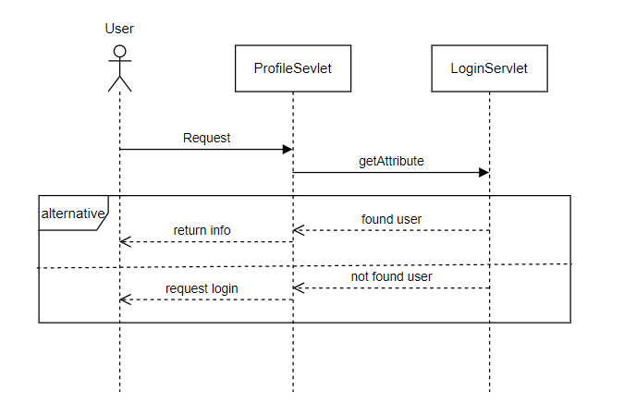

1. **Database Queries**

**3. Update profile**

**a. Class Diagram**

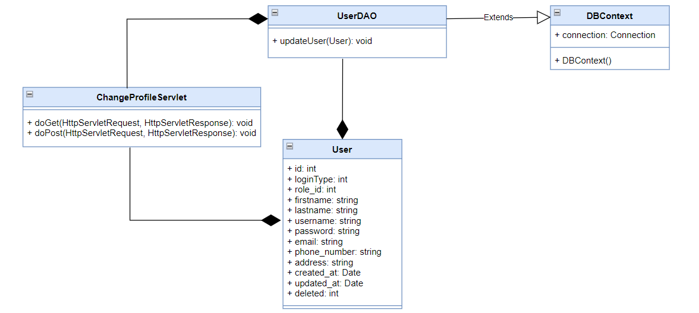

**b. Class specifications**

| **Class** | **Method** | **Description** |
| --- | --- | --- |
| UserDAO | updateUser(User): void | Update information of user in the table Users in the database. |
| DBContext | DBContext() | Connect to the database |
| ChangeProfileServlet | doGet() | Send request to JSP |
| doPost() | Get parameters from JSP and do updateUser() method |

**c. Sequence Diagram**

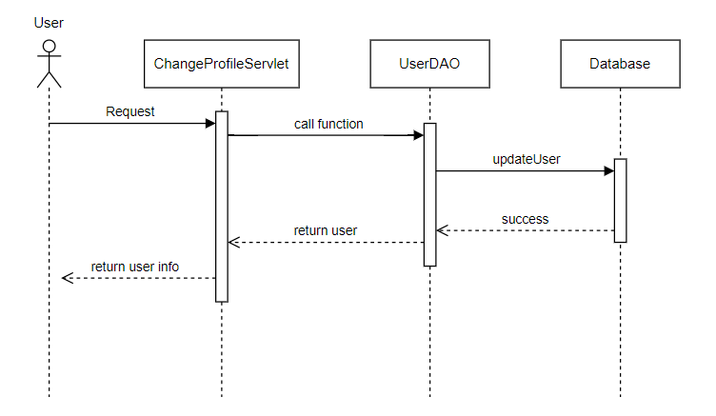

**d. Database Queries**

| **Class** | **Method** | **SQL** |
| --- | --- | --- |
| UserDAO | updateUser(User): void | UPDATE [dbo].[Users]  SET [firstname] = ?  ,[lastname] = ?  ,[phone_number] = ? ,[address] = ?  WHERE username = ? |

**4. Change password**

**a. Class Diagram**

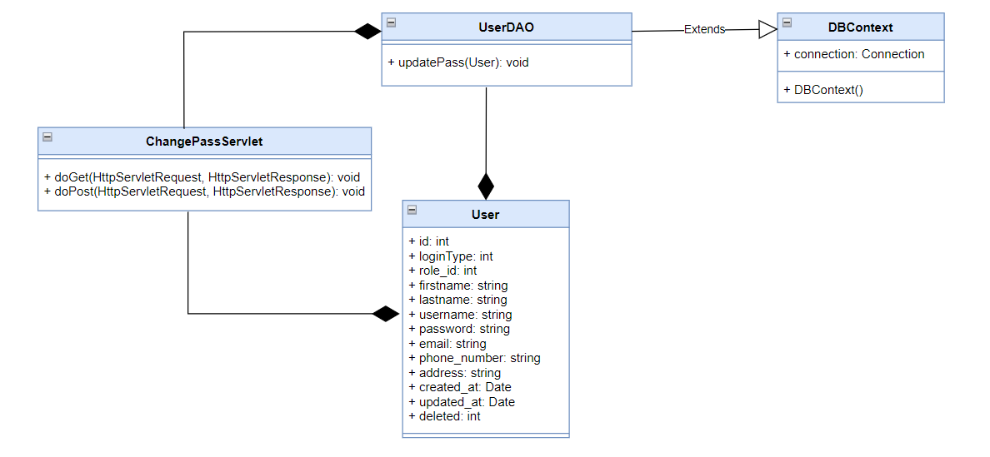

**b. Class specifications**

| **Class** | **Method** | **Description** |
| --- | --- | --- |
| UserDAO | updatePass(User): void | Update pass of user in the table Users in the database. |
| DBContext | DBContext() | Connect to the database |
| ChangePassServlet | doGet() | Send request to JSP |
| doPost() | Get parameters from JSP and do updateUser() method |

**c. Sequence Diagram**

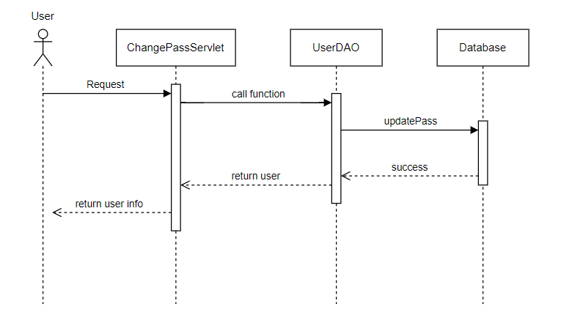

**d. Database Queries**

| **Class** | **Method** | **SQL** |
| --- | --- | --- |
| UserDAO | updatePass(User): void | UPDATE [dbo].[Users] SET [password] = ?  WHERE username = ? |